Ferroelectric Spin-on-Film Based Mach-Zehnder Interferometer

Modulator for 252 Gbit/s PAM4 Transmission
Shiyoshi Yokoyama^{(1,2)}, Jiawei Mao⁽¹⁾, Futa Uemura⁽²⁾, Hiromu Sato⁽¹⁾, Guo-Wei Lu⁽¹⁾

⁽¹⁾ Institute for Materials Chemistry and Engineering, Kyushu University, Fukuoka 816-8580, Japan
⁽²⁾ Department of Molecular and Material Science, Kyushu University, Fukuoka 816-8580, Japan
s_yokoyama@cm.kyushu-u.ac.jp

Abstract We demonstrate a high-speed MZI modulator that is based on a high electro-optic ferroelectric waveguide phase shifter on insulator. The device performs 140 Gbits/ OOK and 253 Gbit/s PAM4 data transmissions. ©2023 The Author(s)

Introduction
Recently, with the emergence of bandwidth-intensive applications such as high-resolution streaming media, B5G, cloud-based service delivery, and the Internet of Things, fiber communication network or data traffic has increased exponentially. This rapid increase in traffic in data communications highlights the increased energy demand in traditional information and communications technologies. Given the implementation cost and power consumption aspects, one of the future challenges is to continue developing core technologies such as transceiver devices and cost-effective optical components. Among the different types of transmitter devices, the high-efficient opto-electric (EO) waveguide modulators have recently received intense research highlights due to the invention of achievable >100 Gbaud signaling with the extremely reduced power consumption. Looking at recent advances of the highly efficient modulator technology, we quickly realize the development of efficient EO materials and thin-film waveguide structure which have received intensive research attentions in microwave photonics and fiber-optic networks. Among the different types of materials used in such waveguide devices, the EO modulators with large EO coefficient (r₃₃>100 pm/V) offer intrinsic advantages of low-voltage driving, RF traveling wave modulation, and compatibility with other waveguide structures.
State-of-the-art efficient modulators rely on various types of EO materials. Particularly, highlight of the polymer modulators can be impressed due to the advantages in fabrication allowed by simple spin-on preparation technique. To date, EO polymer waveguide modulators have shown outstanding performance such as high data rate transmission, low-power consumption, and easy integration to other substrates. The progress makes the modulator device as one of the few possible solutions to realize over 140 Gbaud high-speed signalization [1]. It meets the critical demand in the emerging optical interconnects for short-or middle-reach network. Despite being fast and efficient, reliability issue should be investigated, i.e., stabilities against high-temperature exposure, high-intensity optical signal, humidity exposure, and recycling thermal shock. While progress is significantly being made, careful consideration should be continued to fully address the industrial applications [1], [2]. The heterogeneous integration of strong EO films such as thin-film ferroelectric oxides is the alternative technique.
The ferroelectric oxides with perovskite phase such as PZT (Pb[Zi, Ti]O₃), PLZT([Pb, La][Zi, Ti]O₃) and BTO (BaTiO₃) have recently attracted great attention and some promising devices have been demonstrated based on these materials platform. Particularly, waveguide modulators based on the ferroelectric films-on-insulator (FFOI) have shown great progress in developing the high-frequency modulation [4][5][6]. The modulator applications performed large EO coefficients, low voltage driving, and more compact footprint integration. Reported EO coefficients are 67 pm/V (PZT) 120 pm/V (PLZT), and 342 pm/V (BTO) [7][8][9]. In fabrication, deposition of the ferroelectric oxides on the insulator substrates is of great importance using sputtering, pulse laser deposition, and molecular beam epitaxy techniques. On the other hand, the spin-on-film preparation via a sol-gel chemical reaction is the quick and cost-effective way. In this study, we prepare the PLZT film on SiO₂/Si and fabricate traveling-wave Mach-Zehnder interferometer (MZI) waveguide modulator. We measured EO coefficient of around 200 pm/V and half-wave voltage length (V_{π}⋅L) product of 0.88 V⋅cm at the wavelength of 1550 nm and 0.48 V⋅cm at 1310 nm. The high-speed transmission measurements were performed up to 140 Gbaud, thus we measured 252 Gbit/s PAM4 modulation signals.

Device Design and Fabrication
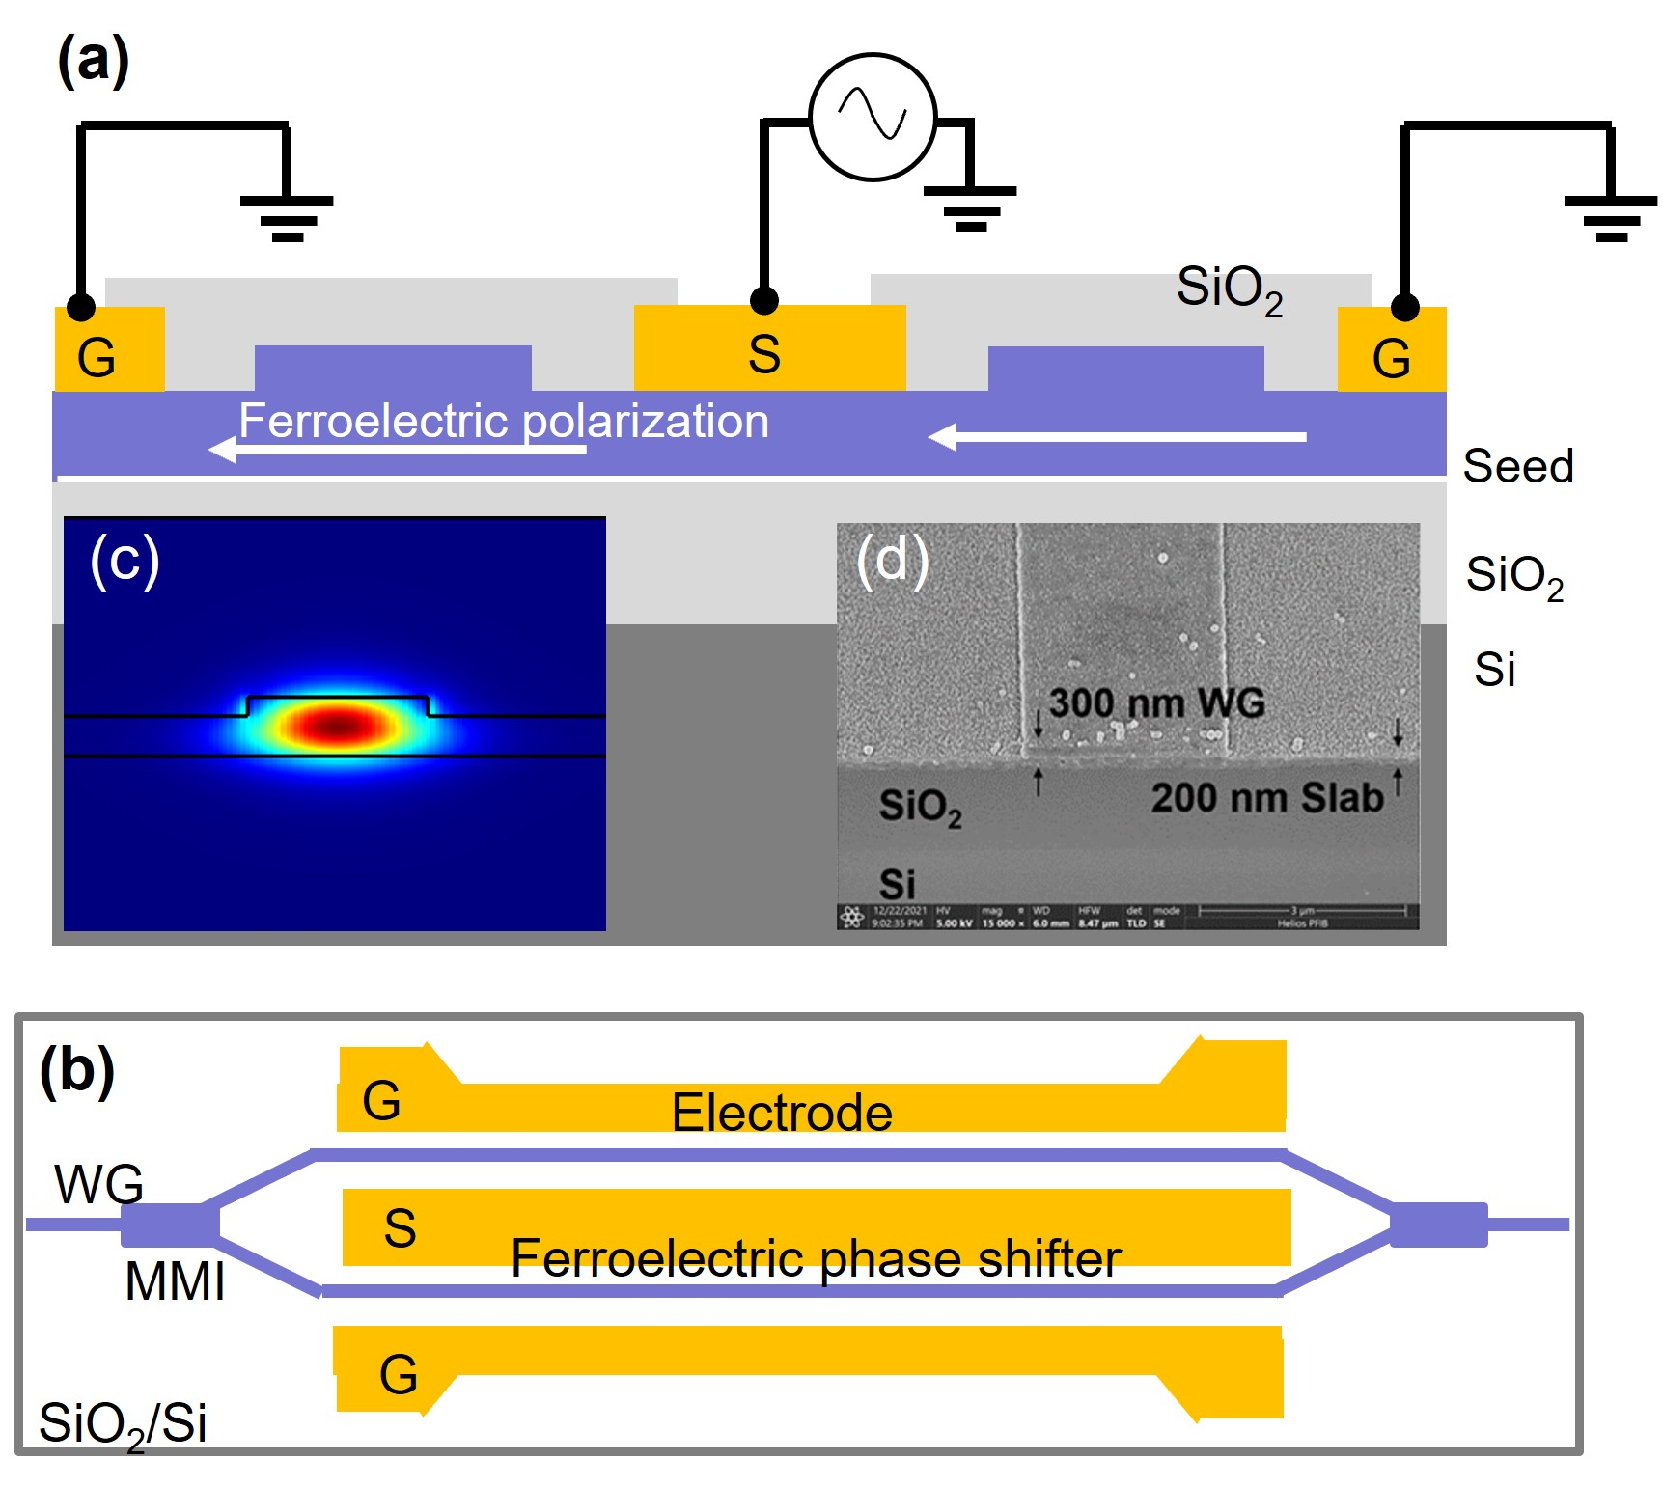
Fig. 1: Schematic diagrams of PLZT MZI modulator. (a) Sectional view of the phase shifter part. (b) Top view of the PLZT modulator. (c) Simulated optical modal distribution in TE mode. (d) SEM image of the waveguide.
The preparation of FFOIs (PZT, PLZT, and BTO on SiO₂/Si) is as follow. The substrate is a commercial Si wafer with a 3-μm thick thermal oxide SiO₂. The surface of SiO₂ is chemically modified with an atomic seed layer, which promotes the crystallization of ferroelectric oxide in desired lattice orientation after appropriate thermal annealing (typically 550°C). The spin-coating and thermal annealing process were repeated several times to obtain a desired film thickness between 300 and 500 nm. The out-of-plane x-ray diffraction signals support a well-defined crystalline orientation in the plane of wafer surface. Such an orientation is necessary for obtaining EO response in co-planer modulation devices. The preparation method is similar for PZT, PLZT, and BTO. In this study, we chose a PLZT on SiO₂/Si in terms of the high Curie temperature (T_{c}). Generally, electrically induced polarization in the crystalline domain of Ferroelectric film vanishes after high-temperature exposure at above T_{c}. PLZT has a relatively high T_{c}>200°C.
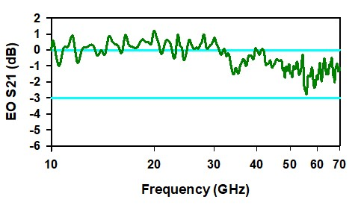Fig. 2: Measured EO frequency response of the PLZT modulator.
Figures 1(a) and (b) show the schematic diagrams of our MZI modulator. The ridge waveguide structure is employed to have the single mode confinement. The simulated TE₀ mode distribution is shown in Fig. 1(c), where the optical modal is tightly confined in the ferroelectric layer due to the large refractive index contrast between PLZT and SiO₂. According to the designed structure to maintain the TE₀ mode, the waveguide was prepared as the ridge height of 100 nm and ridge width of 1.6 μm as shown in the SEM picture of Fig. 1(d). We used the MMI splitters to prepare the phase shifter part. The length of the phase shifter is 2.0 or 3.0 mm. Electrodes are placed on both sides to apply a transverse modulated electric field, and the TE optical mode is preferred in this configuration. Final process is the DC electric poling, where we applied an electric field of 15 V/μm via the electrode microstrip lines at elevated temperatures.

Device Measurements
Since our PLZT waveguide has a large transmission window, the modulator performed both C-band and O-band modulations. We obtained the half-wave voltages (V_{π}) of 3.2 V and 2.5 V at wavelengths of 1550 nm and 1310 nm, respectively. When using a phase shifter model, the effective Pockels coefficient r_{eff} of the PLZT layer can be extracted using r_{eff}=λg/2n³V_{π}LΓ, as 198 pm/V. Here, λ is the laser wavelength, g is the electrode-gap, n is the refractive index, and Γ (74%) is the EO confinement factor which is the optical and electrical overlap factor. It is interesting to compare the values of r_{eff} for PLZT and PZT. As expected, PLZT had an almost doubled r_{eff} compared to the value of PZT [10][11]. Further increase in the r_{eff} can be expected after more detailed crystallization condition and the electric poling process. Measure of details for BTO MZI is under investigation.
For high-frequency modulation in the GHz regime, a traveling-wave electrode must conduct the drive electric signal to the modulator to avoid microwave loss. For this purpose, RF designed electrodes were formed on the phase shifter arm to have a characteristic impedance of close to 50 Ω. The fabricated electrode consists of two parts, namely a microstrip line on the phase shifter and terminal pads. The ground-signal-ground coplanar electrode configuration allows smooth conduction of electric RF signals to the device using RF probes. The bandwidth performance was characterized using a vector network analyser between 10 and 70 GHz. As shown in Fig. 2, the measured EO frequency response of the S21 parameter did not show significant dispersion across the measured frequency range, indicating the 3 dB bandwidth of the modulator beyond 70 GHz. A drop in the EO response can be observed in the range of 1 to 10 GHz, which might be attributed the imperfect design of the electrode.
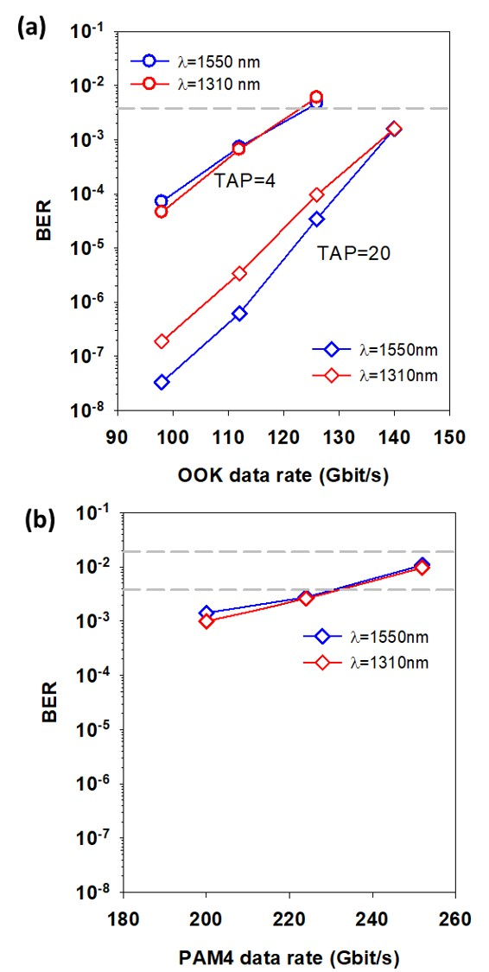
Fig. 4: BER at different data rates. (a) OOK. (b) PAM4.
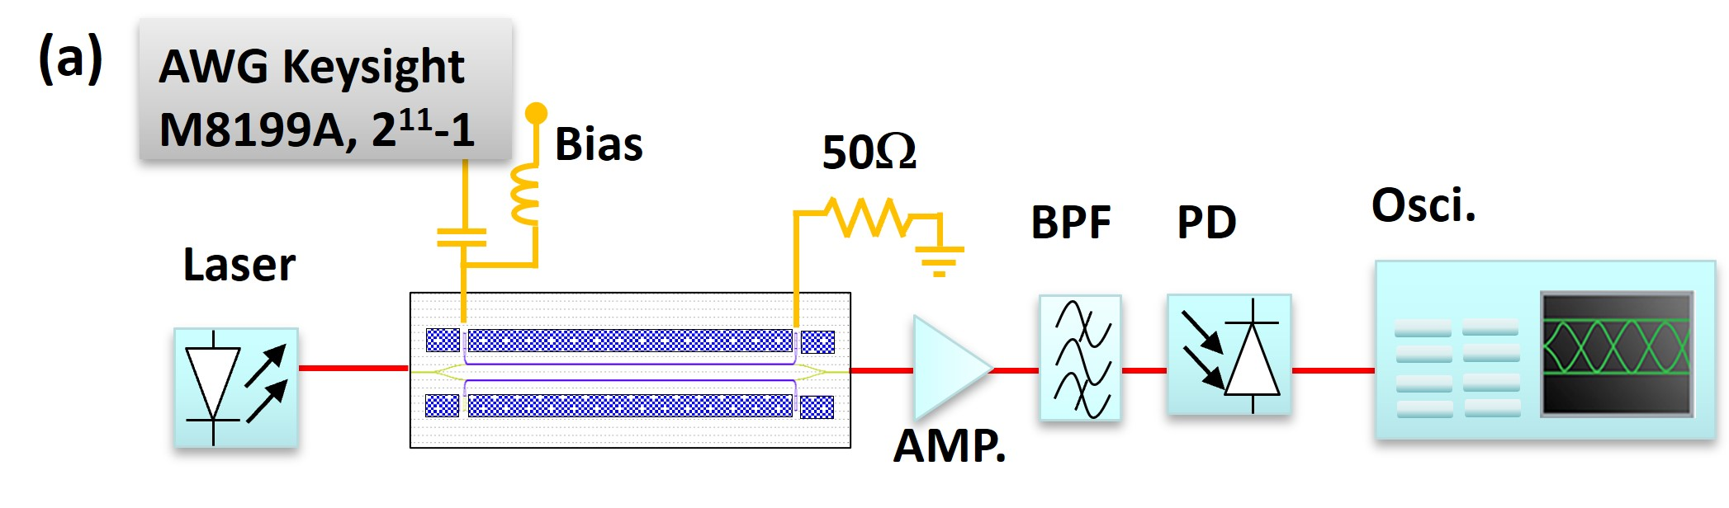
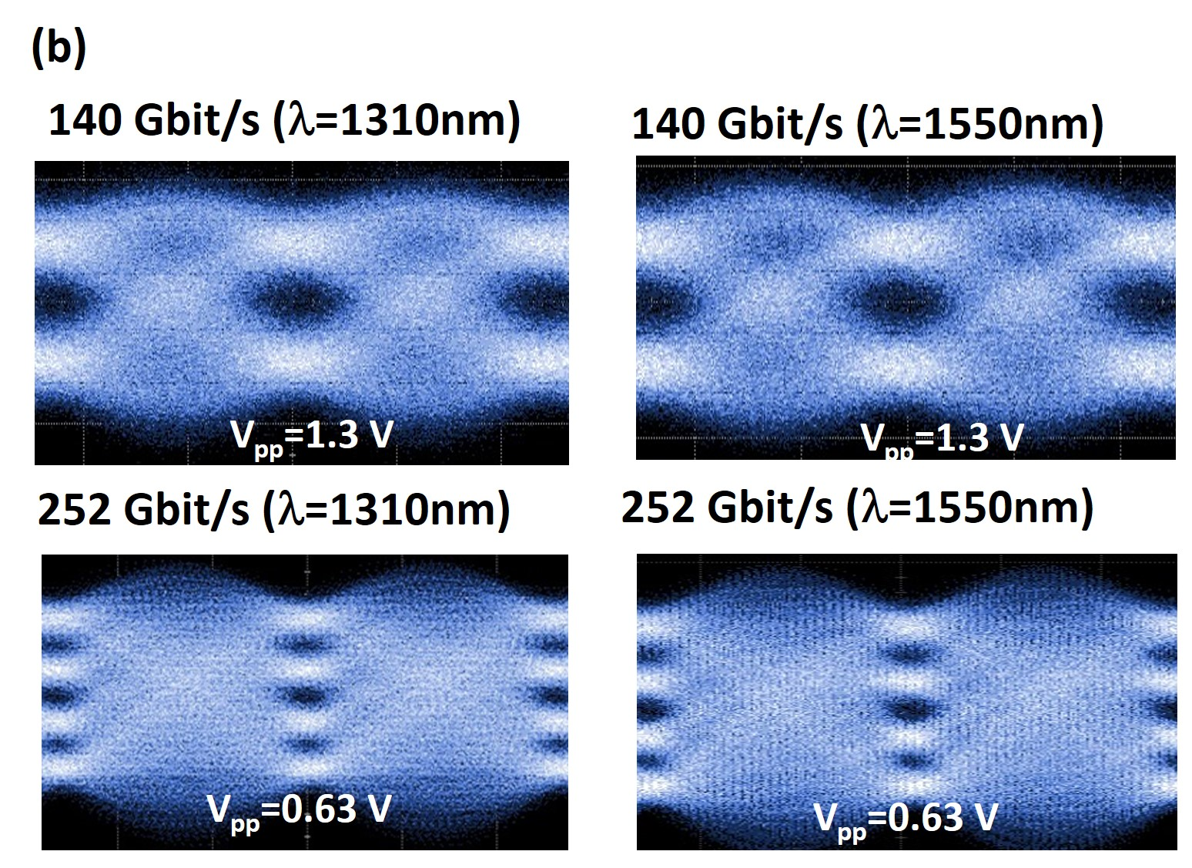
Fig. 3: Data transmission. (a) Experimental setup for OOK and PAM4 transmisisons. (b) Measured eye patterns for OOK and PAM4 for different data rates.

High Speed Modulation
Figure 3(a) represents the experimental setup for testing the high-speed serial data modulation. The CW light from the laser is modulated by applying the electric driving singles. A electrical signal with a pattern length of 2¹¹-1 was produced using an arbitrary waveform generator (AWG, M8199A Keysight) at a sampling rate of 256 GSa/s. The optical signal was received by a 70 GHz signal photodetector (PD XPDV3320R, II-V) after passing through an optical fiber amplifier and a band-pass filter, and then, fed to an oscilloscope (DCA86116C and UXR1102A, Keysight) for eye-pattern generation and BER analysis. Figure 3(b) show the measured eye patterns for OOK at wavelengths of 1550 nm and 1310 nm. Clear eye signals were obtained for both laser sources after the standard offline process using the feed-forward equalizer and transmitter distortion eye closure quaternary. The EO (Pockel’s effect) intensity modulators generally exhibit excellent EO linearity. Thus, it will be a challenge to double the data rate of our modulator from single 126 Gbit/s OOK to 252 Gbit/s PAM4. In the measured PAM4 as shown in Fig. 3(b), the modulator maintains the baud rate of 126 Gbaud, while increasing the signal rate of the transmission. In the experiment, PAM4 modulation was tested by simply replacing the signal source (i.e., no changes were made to the modulator). The bit error rate (BER) analyses result at different data rates for OOK and PAM4 are shown in Fig. 4. The 142 Gbit/s OOK and 252 Gbit/s PAM4 signals can be achieved below the 7% HD-FEC threshold and 20% HD-FEC threshold, respectively.

Conclusions
We present fabrication and modulation of the ferroelectric oxide (PLZT) based high-speed modulator. The waveguide device can be obtained through simple fabrication techniques with cost effective ways. The measured results show considerable promise for the efficient modulator applications.

Acknowledgements
This work was supported in part by MEXT under Grant JP19H00770, JP23H00188; in part by JST under Grant JPMJMS2063; in part by NICT under Grand 02101.

References
- G.-W. Lu, J. Hong, F. Qiu, A. M. Spring, T. Kashino, J. Oshima, M. Ozawa, H. Nawata, and S. Yokoyama, “High-temperature-resistant silicon-polymer hybrid modulator operating at up to 200 Gbit s−1 for energy-efficient datacentres and harsh-environment applications”, Nature Communications, 11, 4224 1-7, 2020,

Doi: 10.1038/s41467-020-18005-7
- H. Sato, J. Mao, A. Bannaron, T. Kamiya, G.-W. Lu, and S. Yokoyama, “A 100 Gbaud On-off-keying Silicon-Polymer Hybrid Modulator Operating at up to 110°C”, IEEE Photonics Technology Letters, 33, 1507-1510, 2021,

DOI: 10.1109/LPT.2021.3126945
- J. Mao, H. Sato, G.-W. Lu, and S. Yokoyama, “Heterogeneous silicon-on-lithium niobate electro-optic modulator for 100-Gbaud modulation”, APL Photonics 7, 126103-1-7, 2022,

DOI: 10.1063/5.0109251
- J. E. Ortmann, F. Eltes, D. Caimi, N. Meier, A. A. Demkov, L. Czornomaz, J. Fompeyrine, and S. Abel, ACS Photonics, 6, 2677-2684, 2019,

DOI: 10.1021/acsphotonics.9b00558
- A. Messner, F. Eltes, P. Ma, S. Abe, B. Baeuerle, A. Josten, W. Heni, D. Caimi, J. Fompeyrine, and J. Leuthold, “Plasmonic Ferroelectric Modulators”, J. Lightwave Technology, 37, 281-290. 2019,

DOI: 0.1109/JLT.2018.2881332
- F. Eltes, C. Mai, D. Caimi, M. Kroh, Y. Popoff, G. Winzer, and D. Petousi, S. Lischke, J. E. Ortmann, L. Czornomaz, L. Zimmermann, J. Fompeyrine, and Stefan Abel, “A BaTiO3-Based Electro-Optic Pockels Modulator Monolithically Integrated on an Advanced Silicon Photonics Platform”, J. Lightwave Technology, 37, 1456-1462, 2019,

DOI: 10.1109/JLT.2019.2893500
- K. Alexander, J. P. George, J. Verbist, K. Neyts, B. Kuyken, D. Van Thourhout, and J. Beeckman, “Nanophotonic Pockels modulators on a silicon nitride platform”, Nature Comm., 9, 3444, 2018,

DOI: 10.1038/s41467-018-05846-6
- S. Abe, T. Joichi, K. Uekusa, H. Hara, and S. Masuda, “Photonic integration based on a ferroelectric thin-film platform”, Scientific Rep., 9, 16548, 2019,

DOI: 10.1038/s41598-019-52895-y
- S. Abel, F. Eltes, J. E. Ortmann, A. Messner, P. Castera, T. Wagner, D. Urbonas, A. Rosa, A. M. Gutierrez, D. Tulli, P. Ma, B. Baeuerle, A. Josten, W. Heni, D. Caimi, L. Czornomaz, A. A. Demkov, J. Leuthold, P. Sanchis, and J. Fompeyrine, “Large Pockels effect in micro- and nanostructured barium titanate integrated on silicon”, Nature Mater., 18, 42-47, 2019,

DOI: 10.1038/s41563-018-0208-0
- S. Masuda, A. Seki, K. Shiota, H. Hara, and Y. Masuda, “Electro-optic and dielectric characterization of ferroelectric films for high-speed optical waveguide modulators”, J. Appl. Phys., 109, 124108, 2018,

DOI: 10.1063/1.3598107
- C. Huang, D. Li, T. He, Y. Peng, W. Zhou, Z. Yang, J. Xu, and Q. Wang, “Large quadratic electro-optic effect of the PLZT thin films for optical communication integrated devices”, ACS Photoncis, 7, 3166-3176, 2020,

DOI: 10.1021/acsphotonics.0c01234

